Lab 6: Using Machine Learning for Anomaly Detection and Forecasting

© 2024 Amazon Web Services, Inc. or its affiliates. All rights reserved. This work may not be reproduced or redistributed, in whole or in part, without prior written permission from Amazon Web Services, Inc. Commercial copying, lending, or selling is prohibited. All trademarks are the property of their owners.

Note: Do not include any personal, identifying, or confidential information into the lab environment. Information entered may be visible to others.

Corrections, feedback, or other questions? Contact us at [*AWS Training and Certification*](https://support.aws.amazon.com/#/contacts/aws-training).

**Lab overview**

Now that AnyCompany Software has fully adopted Amazon QuickSight, your team wants to explore machine learning integration in QuickSight dashboards. You are investigating how QuickSight can use machine learning to forecast data and detect data anomalies to improve AnyCompany Software’s competitive edge.

In this lab, you create machine learning forecasts and detect anomalies in a dataset using the machine learning features of QuickSight.

OBJECTIVES

By the end of this lab, you should be able to do the following:

* Use the machine learning features of QuickSight to add forecasts to a visualization.
* Customize formatting in a narrative to provide text-based insights on a dashboard.
* Perform anomaly detection in a dataset and a contribution analysis.

DURATION

This lab requires approximately *45* minutes to complete.

ICON KEY

Various icons are used throughout this lab to call attention to different types of instructions and notes. The following list explains the purpose for each icon:

* **Expected output:** A sample output that you can use to verify the output of a command or edited file.
* **Note:** A hint, tip, or important guidance.
* **Learn more:** Where to find more information.
* **Caution:** Information of special interest or importance (not so important to cause problems with the equipment or data if you miss it, but it could result in the need to repeat certain steps).
* **Consider:** A moment to pause to consider how you might apply a concept in your own environment or to initiate a conversation about the topic at hand.
* **Task complete:** A conclusion or summary point in the lab.

**Start lab**

1. To launch the lab, at the top of the page, choose Start lab.

**Caution:** You must wait for the provisioned AWS services to be ready before you can continue.

1. To open the lab, choose Open Console.

You are automatically signed in to the AWS Management Console in a new web browser tab.

**WARNING:** **Do not change the Region unless instructed.**

COMMON SIGN-IN ERRORS

**Error: You must first sign out**

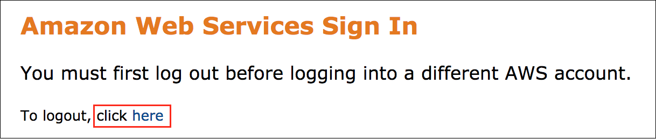

If you see the message, **You must first log out before logging into a different AWS account:**

* Choose the **click here** link.
* Close your **Amazon Web Services Sign In** web browser tab and return to your initial lab page.
* Choose Open Console again.

**Error: Choosing Start Lab has no effect**

In some cases, certain pop-up or script blocker web browser extensions might prevent the **Start Lab** button from working as intended. If you experience an issue starting the lab:

* Add the lab domain name to your pop-up or script blocker’s allow list or turn it off.
* Refresh the page and try again.

AWS SERVICES NOT USED IN THIS LAB

AWS service capabilities used in this lab are limited to what the lab requires. Expect errors when accessing other services or performing actions beyond those provided in this lab guide.

**Task 1: Add multi-metric forecasting**

Your team wants to improve the dashboard data-to-ink ratio and would like to show two forecasted trends on the same line chart.

In this task, you add profit data to the sales visualization.

1. At the top of the **AWS Management Console**, in the search bar, search for and choose

.

1. From the **Analyses** page, choose **quicksight-lab-6**.
2. Choose the **Sum of Sales by Order Date** line chart visualization.
3. In the navigation pane at the top of the page, in the **Fields list** pane, choose **Profit** to add it to the sales visualization.

**Caution:** You might need to expand the **Metrics** folder to see the **Profit** field. You can also enter any field name into **Search fields**.

**Expected output:** A profit line appears on the line chart with a forecast.

**Learn more:** Hover over the forecast range for either **Sales** or **Profit** to see the **Expected** forecast value along with the **Upper Bound** and **Lower Bound** values. QuickSight provides these values to help you analyze the forecasts in more detail. Each forecast is computed independently of other fields in the line chart. For more information about forecasts, see [Forecasting and creating what-if scenarios with Amazon QuickSight](https://docs.aws.amazon.com/quicksight/latest/user/forecasts-and-whatifs.html) in the *Amazon QuickSight User Guide*.

**Task complete:** You have completed **Task 1** by adding multi-metric forecasting to a visualization.

**Task 2: Customize formatting in an automated insight**

As part of an ongoing effort to build dynamic narratives in the dashboard, your team wants to adjust the formatting in an automated insight to highlight important information.

In this task, you customize text formatting in an automated insight.

1. On the sales dashboard, choose the **Period over period** insight.
2. In the visualization menu on the right of your **Period over period** insight, choose the **Menu options** ellipsis icon and choose **Customize narrative**.
3. In the **Edit narrative** workspace, choose the **increased by** text.
4. Choose the **Abc** text color icon.
5. For **HEX**, enter

 to change the color.

1. Choose **Apply**.
2. In the **Edit narrative** workspace, choose the **decreased by** text.
3. Choose the **Abc** text color icon.
4. For **HEX**, enter

 to change the color.

1. Choose **Apply**.
2. At the end of the narrative, choose the **PeriodOverPeriod.currentMetricValue.formattedValue** block.
3. Choose the text inside the expression editor, and choose the **Bold** icon.
4. Choose **Save** to finalize the narrative customizations.

**Expected output:** When the period over period sales increase, the narrative text is one color. When the sales decrease, the narrative text is another color. The final sales result for the period now appears in bold.

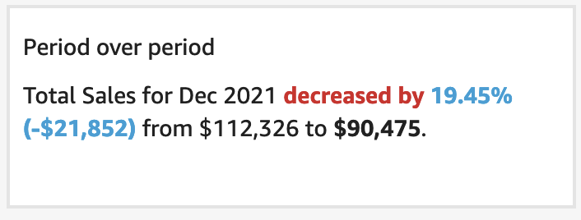

*Image description: The preceding image shows the period over period visualization with updated formatting.*

**Task complete:** You have completed **Task 2** by customizing an automated insight.

**Task 3: Edit forecast computations in a narrative**

You want to edit the sales forecast visualization on the dashboard, outlining the forecasts for sales over a 6-month period and a 12-month period. This gives your sales team more projections to analyze.

In this task, you edit a forecast and add new information to a custom narrative.

TASK 3.1: EDIT THE PERIOD COMPUTATIONS AND DETAILS

Edit the custom forecast narrative to outline the 6-month sales forecast.

1. On the sales dashboard, choose the **Forecast** insight.
2. In the visualization menu on the right of your **Forecast** insight, select the **Menu options** ellipsis icon and select **Customize narrative**.
3. Choose **Computations** to expand the computations menu.
4. Next to **ForecastInsight**, choose the **Configure forecast** pencil icon.
5. In the **Configure forecast** menu, for **Periods Forward**, enter

.

1. Choose **Save**.
2. In the **Edit narrative** workspace, delete the

 text.

1. At the beginning of the narrative, enter

.

**Expected output:** You have started to customize the narrative.

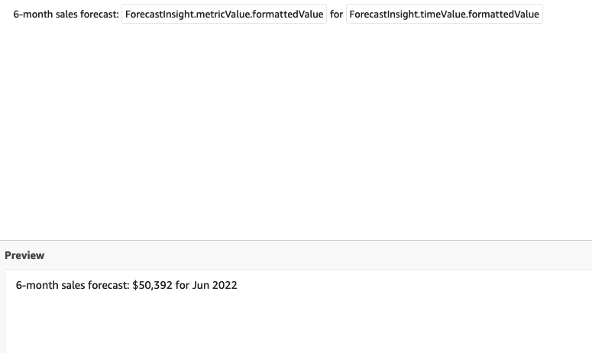

*Image description: The preceding image shows the narrative workspace.*

**Learn more:** With custom machine learning forecasts, QuickSight offers reliable, computation-driven narrative reporting that you can implement quickly.

TASK 3.2: ADD A NEW FORECAST TO THE NARRATIVE

Add the 12-month forecast to the narrative.

1. Choose **+ Add computation**.
2. For **Computation type**, choose **Forecast**.

**Consider:** Take a moment to look through the list of computations. Which ones are powered by machine learning?

1. Choose **Next**.
2. For **Periods Forward**, enter

.

**Note:** This new sales forecast is named **ForecastInsight2**.

1. Choose **Add**.
2. In the **Edit narrative** workspace, place your cursor at the end of the sentence and use the Enter key on your keyboard to start a new line in the narrative editor.
3. Type

.

1. Choose **Computations** to expand the computations menu.
2. To add an expression to the narrative editor, under **ForecastInsight2**, choose the arrow next to **metricValue** and choose **formattedValue**.
3. After the expression, press the Space bar and then enter

.

1. To add an expression to the narrative editor, in the **Computations menu**, under **ForecastInsight2**, choose the arrow next to **timeValue** and choose **formattedValue**.

**Expected output:** You have two similar sentences, one that shows a 6-month forecast, and one that shows a 12-month forecast.

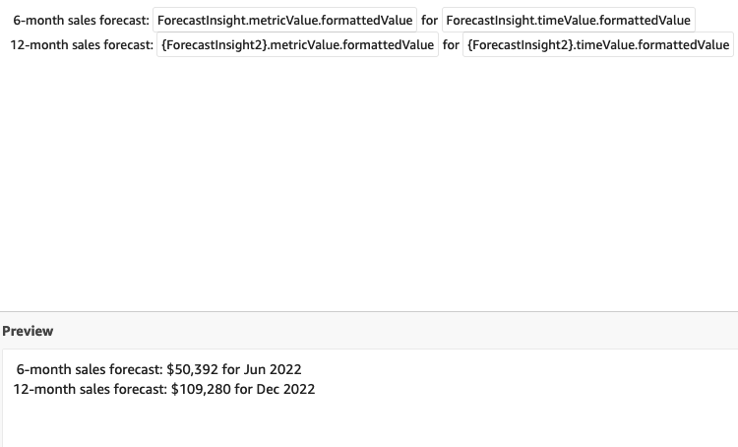

*Image description: The preceding image shows the narrative workspace with two sentences.*

1. To finalize the narrative customizations, choose **Save**.

**Task complete:** You have completed **Task 3** by editing forecast computations in a narrative.

**Task 4: Add an anomaly detection insight**

You want to add an anomaly detection insight to the dashboard that highlights key outliers in the sales data. QuickSight has a machine learning insight that combs through the underlying data looking for anomalies to report.

In this task, you add an anomaly detection insight to the dashboard and conduct anomaly detection.

TASK 4.1: ADD AN ANOMALY DETECTION INSIGHT TO THE DASHBOARD

Add an anomaly detection insight that uses the *Country*, *Customer*, *Order Date*, and *Sales* fields.

1. In the top menu bar, choose **Insert**.
2. Choose **Add insight**.
3. For **Computation type**, choose **Anomaly detection**.
4. Choose **Select**.
5. In the **Fields list** pane, choose **Country**, **Customer**, **Order Date**, and **Sales**.

**Note:** You might need to expand the **Date** and **Metrics** folder to add **Order Date** and **Sales**.

1. Next to **Order Date**, choose the ellipsis icon.
2. Hover over **Aggregate: Day** and choose **Month** to change the aggregation to month.
3. In the navigation pane at the top of the page, choose **Filter**.
4. To expand the filter options, choose the **Region** filter.
5. Choose **All applicable visuals** and choose **Some visuals**.
6. Select all of the visuals from the list except for **Insight**.

**Note:** Leaving the *Insight* visual unselected in the list removes the *Region* filter from the *Insight* visual to let anomaly detection analyze all of the data in the dataset.

1. Choose **APPLY**.

**Expected output:** Your anomaly detection insight is ready to analyze your dataset.

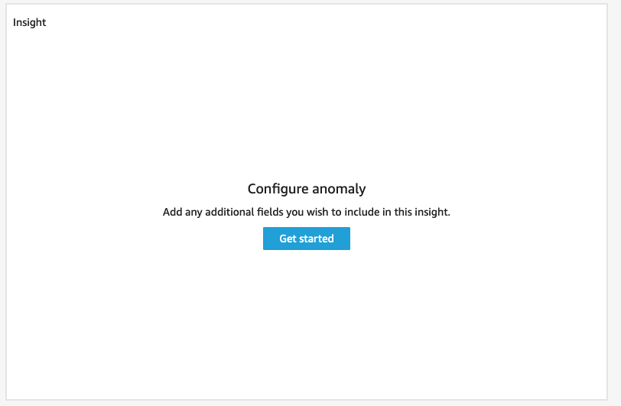

*Image description: The preceding image shows the anomaly detection insight visualization, with a get started button.*

TASK 4.2: CONDUCT ANOMALY DETECTION

Now that you have created your anomaly detection insight, finish the configuration steps and run the anomaly detection on the fields you selected.

1. On the **Insight**, choose **Get started**.
2. In the **Combinations to be analyzed** section, expand the dropdown list and choose **All** to include as many levels as possible in the analysis.
3. To expand the top contributors section, choose **Top contributors**.
4. In the **Select fields** section, expand the dropdown list and choose **Contact Name**, **Country**, and **Product**.

A preview appears on the right side of the page.

1. Choose **Save**.
2. On the **Insight**, choose **Run now**.

**Expected output:** The analysis takes a few minutes to run. You can either wait for it, or move on to the next task and then come back to the insight to view the results.

**Consider:** How can you use anomaly detection to draw out insights that your company may otherwise miss without implementing machine learning techniques? Are there any adjustments you would make to the fields included in the anomaly detection to investigate other anomalies in the data?

**Task complete:** You have completed **Task 4** by adding an anomaly detection insight to your dashboard. You added the insight and then conducted anomaly detection.

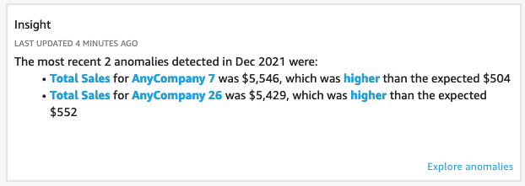

*Image description: The preceding image shows the anomaly detection visualization results.*

**Task 5: Perform a contribution analysis with anomaly detection**

Your team now knows how to customize machine learning forecast narratives, adjust parameters and control values to impact conditional IF statements in narratives, and run anomaly detection on a dataset. As a final step, you decide to run an anomaly detection on the sales line chart to create a contribution analysis.

In this task, you run anomaly detection on the sales line chart to see how the *Country*, *Customer*, and *Product* fields contribute to the sales results.

TASK 5.1: ANALYZE WHICH FIELDS IMPACT SALES

Analyze contributions to sales in the sales line chart.

1. In the **Sum of Sales by Order Date** line chart visualization, hover over the **Sales** line and open (right-click) the data point for **Sep 2020**.
2. From the list, choose **Analyze contributions to Sales**.
3. In the **Top contributors** section, choose **Country**, **Customer**, and **Product**.
4. Choose **ANALYZE**.

**Expected output:** A list of Top Contributors appears to the left of the dashboard.

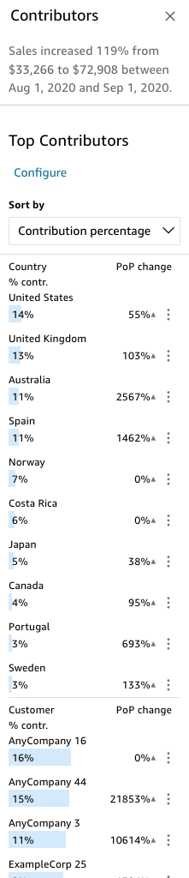

*Image description: The preceding image shows the top contributors listed.*

**Consider:** Take a minute to explore the contribution analysis. If you hover over a finding, QuickSight provides a short explanation of what the contribution was and if it was higher or lower than anticipated.

TASK 5.2: EXPLORE TOP CONTRIBUTORS IN YOUR ANOMALY DETECTION INSIGHT

Find out what the top contributors were in the anomaly that QuickSight detected.

1. In the visualization menu on the right of your **Insight visual**, choose the **Menu options** ellipsis icon and choose **Explore anomalies**.
2. In the **Top Contributors** section, choose **Configure**.

**Note:** You might need to refresh the page to see Top Contributors.

1. Choose **City** to add it to the list of **Selected fields**.
2. Choose **ANALYZE**.
3. Scroll down the list until you see which cities contributed to the anomaly.

**Task complete:** You have completed **Task 5** by performing a contribution analysis with anomaly detection.

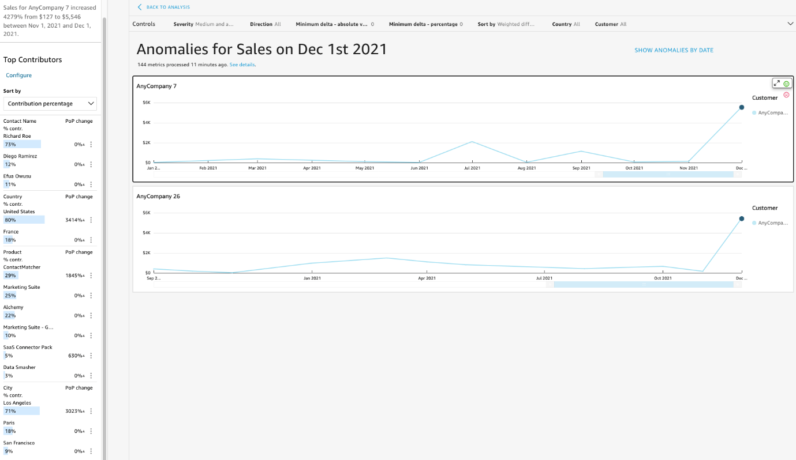

*Image description: The preceding image shows the sales anomalies.*

**Conclusion**

You have successfully done the following:

* Used the machine learning features of QuickSight to add forecasts to a visualization
* Customized formatting in a narrative to provide text-based insights on a dashboard
* Performed anomaly detection in a dataset and a contribution analysis

**End lab**

Follow these steps to close out the console and end your lab.

1. At the upper-right corner of the QuickSight console, choose the user icon and then choose **Sign out**.
2. On this screen, choose **End lab** and then confirm that you want to end your lab.